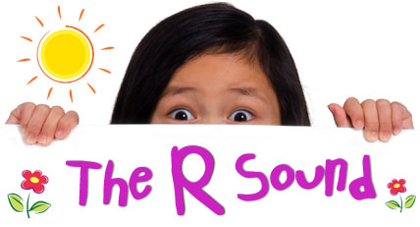
Hi, and welcome to /r/101. I call it this, because it truly is the basics of what you need to know about this complex sound. I want to help you understand where you fit into the equation when it comes to improving articulation for your child. I will cover questions that I most frequently hear from parents.
- Why is the /r/ sound so commonly not able to be produced?
- It is actually not one sound, it is many sounds, depending on the letters it is paired with. AR, AIR, EAR, ER, OR, and IRE are the 6 vocalic /r/ sounds. For each of these sounds the tongue has a different position in the mouth and a different amount of air pushed through at the same time. It is more complicated than one might think.
- Why can I notice the lack of /r/ more than other speech sounds. /r/ is one of the most used sounds in the English language and thus poses more issues with intelligibility.
- What can we do at home to help? There is no one way to correct the problem. The /r/ can be produced in different ways and depending on your child, they will need different instruction. The best thing you can do is to encourage them, and help them relax. If you are stressed they aren’t getting it, then it will translate to them.
- Where do I fit in? Communicate often with your child’s Speech Teacher. They will have specific information on what has and hasn’t been working. In the beginning you may be “sitting the bench”, but once your child is able to produce that sound then you will PRACTICE-PRACTICE-PRACTICE with them every day to help make it prevalent and then permanent in their conversational speech.

